**University Of Massachusetts Dartmouth**

Drew A Martins

December 9, 2019

ECE – 9 Acoustic Awareness Enabler

ECE 457- Design Project 1

**Customer:**

Dr. Karen Payton

**Advisor:**

Dr. W. Vance. McCollough

**Authors:**

Drew Martins

Jared Alves

Michael Benker

Stephen Felix

Ryan Dumont

Table of Contents

Changes Made to CDR 3

Introduction 3

Concept of Operations 3

Customer Requirements 4

Engineering Requirements 5

Current PDR Accomplishments 7

Preliminary Enclosure Outline 7

Initial PCB Layout 7

Preliminary Design Schematic 7

Electrical Testing 7

Functional Flowchart 7

Signal Processing 7

AVR Programming 7

Risk Analysis 7

Updated GANTT Schedule 7

Earned Value Assessment 8

Evaluation of Engineering Requirements Progress 8

Conclusion 8

*Table Headings go at the top*

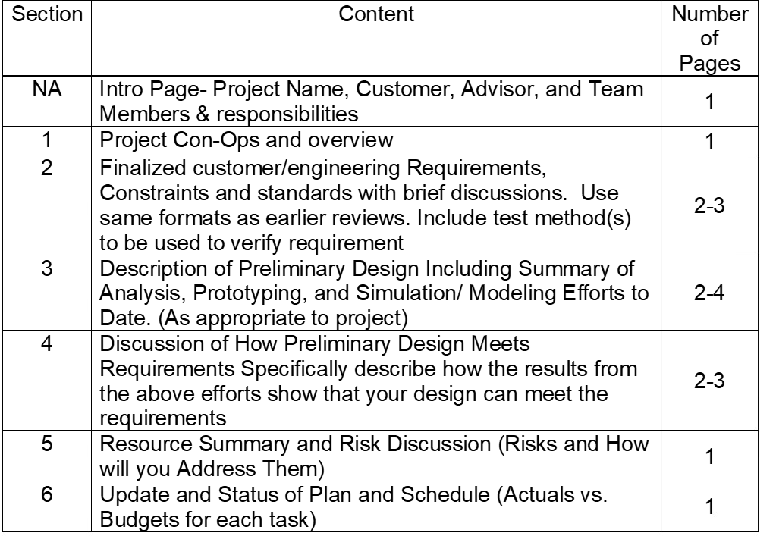

(Just leave the chart here until we turn in it on Monday December 9)

# Changes Made to CDR

## Introduction

The Acoustic Awareness Enabler is the project were a small device connected to an audio playing device and headphones that pauses the audio playing whenever an interrupt in the environment occurs, like the calling of your name. A microphone is in the device to determine the ambient sound level of the room and then any interrupts that happen. The device will also contain 3 buttons, Quiet, Medium, and loud, that sets the sensitivity of the device to those interrupts. The Quiet button sets the device to trigger the volume to decrease in the headphones when a “quiet’ interrupt occurs and vice versa the Loud button triggers the volume to decrease when a “loud” interrupt occurs. These Interrupts of course are in relation to the different in the ambient sound level in the environment. With MATLAB and physical data recorded, it became possible to create a mathematical formula for detecting the interrupts.

## Concept of Operations

## Customer Requirements

|  |  |
| --- | --- |
| **#​​** | **Requirement Description** |
| 1​​ | Power source must be self-contained and have a life of 8 hours.​​ |
| 2​​ | Must have a 3.5mm female audio jack for the input and output.​​ |
| 3​​ | Must have 3 different levels of interruption noise sensitivity (High, Medium and Low sensitivity).​​ |
| 4​​ | When interruption is detected, the volume of the noise going through users' headphones must be muted or lowered.​​ |
| 5​​ | Must be able to distinguish between ambient and interrupt with a 1% false interrupt detection rate.​​ |
| 6​​ | Must have a reset button to restart the audio ​​ |
| 7​​ | Separate audio cable between device and audio source. ​​ |

**Table 1 Customer Requirements**

As shown in Table 1, the customer requirements remained unchanged from the Concept Design Review.

## Engineering Requirements

The changes that were made are highlighted in red. Now that most of the important parts got shipped in, testing the battery life became plausible measuring the amount of voltage each component like the microphone uses and the circuitry to see the type of battery will be chosen to last that long. Also now we can add the audio jacks to the circuity to see if works properly. Data collecting was finished so the data was use to model how to calculate the threshold levels for the three different sensitivity levels of the interrupt. And lastly, since testing the auxiliary ports we got a cable to connect it to audio device.

|  |  |  |  |  |
| --- | --- | --- | --- | --- |
| **Requirement** | **Customer Requirements​** | **Engineering Requirements​** | **Justification/Comments​** | **Test Methods​** |
| 1​ | Self-containment of power source (rechargeable) and battery life of 8 hours​ | 1.1 8 hours of power supplied to device​ | Device needs an independent power source because it is not being supplied by the audio source​ | Testing amperage draw from circuit and using that information to choose a battery to last 8 hours.​ |
| 2​ | 3.5mm audio jack for input and output​ | 2.1 Audio Source Input 3.5mm ​ | The input is for the device to be connected to the phone or audio source. The output is connected to a pair of headphones. In between the input (L/R) and output (L/R) is a digital potentiometer/switch that reduces the volume of the audio source to the output.​ | Inserted audio jacks in circuit for input and output and verify functionality on a breadboard.​ |
| 2.2 Audio Source Output 3.5mm​ |
| 2.3 I/O interface – digital potentiometer/switch​ |
| 3​ | Must have 3 different levels of interruption noise sensitivity (High, Medium and Low sensitivity)​ | 3.1 Must create MATLAB programs to take in data to provide averages and standard deviations to base sensitivity levels on​ | The user will select a sensitivity level through the interface buttons. The sensitivity levels will be relative to the ambient level measured by the device.​ | Data collection of samples of real-world interruption thresholds were completed. Data was modeled in MATLAB to calculate the threshold levels as a function of the ambient average and standard deviation.​ |
| 3.2 Three separate sensitivity buttons​ |
| 4​ | When interruption is detected, the volume of the noise going through users’ headphones must be muted or lowered​ | 4.1 Use of potentiometers/switches to attenuate audio​ | Potentiometers or switches?​ | Lab testing of potentiometers/switches for reduction of audio signal​ |
| 5​ | Must be able to distinguish between ambient and interrupt with a 1% false interrupt detection rate​ | 5.1 Comparison of data sets will show a range of ambient dB levels that will yield a 1% false detection rate or better​ | Ensures reliability. Preference is for audio to continue uninterrupted. Failure can be caused by failing to attenuate audio or device interprets a deviance in ambient noise as an interrupt​ | MATLAB plots show curves of ambient data and interrupts which show overlapping for possible false interrupt detection. MATLAB threshold algorithm will be used to process audio at correct sample rate and determine information about signal (average, standard deviation)​ |
| 5.2 Lowest Ambient Noise of 30 dB based on ANSI standards​ |
| 5.3 Must have 100 Hz Sampling frequency to detect averages in sound (not reconstructing signal)​ |
| 5.4 Need a sound level detector ​ |
| 6​ | Must have a reset button to restart audio ​ | 6.1 Physical reset button will be present on Acoustic Awareness enabler to start the resetting of audio signal.​ | Need to resume original audio after it is attenuated​ | Lab testing for potentiometers for increase of audio signal​ |
| 6.2 Use of potentiometers/switches to resume audio after reset button has been pressed.​ |
| 6.3 Button will recalibrate device and will delay further interrupts for 20 seconds while gathering data​ |
| 7​ | Separate audio cable between device and audio source​ | (Requires no further engineering, will be included with final product)​ | Connects device to audio source, reduces overall form factor. ​ | Cable used in lab testing for auxiliary port/audio and switch integration.​ |

**Table 2: Engineering Requirements**

1. Constraints

So far, our constraints mainly stayed the same as well. First one is the portability, the device needs to be carried with a set of headphones. Also, form factor being that the device itself is small and is able to fit into your pocket. Another constraint is the availability of the components meaning are we able to get all the components we need and in on time. The budget for the device is also limited but manageable. And lastly time, the project must be completed by spring of 2020.

1. Standards
   1. IEEE Code of Ethics​
   2. Microcontroller/Coding – ATMega328PB, C Programming, AVR, C++​
   3. ​3.5mm Auxiliary Port​
   4. Sound Level - IEC 652 TYPE2 and ANSI S1.4 TYPE2​
   5. I2C and SPI Standards: 7-Bit Addressing​
   6. IEC62133 – Battery Safety for Lithium Polymer Batteries​
   7. Electrical Enclosures – IP40, NEMA 1

Mainly the standards stayed the same except two more was added for the battery and a enclosure, a case, for the device’s components.

# Current PDR Accomplishments

## Preliminary Enclosure Outline

## Initial PCB Layout

## Preliminary Design Schematic

## Electrical Testing

## Functional Flowchart

## Signal Processing

## AVR Programming

## Risk Analysis

## Updated GANTT Schedule

## Earned Value Assessment

## Evaluation of Engineering Requirements Progress

# Conclusion